1. **Term**: Avro Schema processor.  
   A close-up of a text

   Description automatically generated
2. 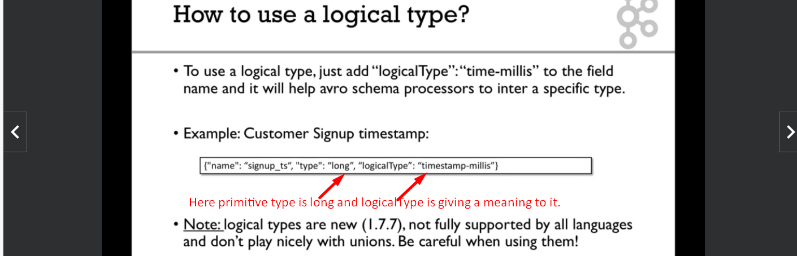
3. A computer screen shot of text

   Description automatically generated